- PURPOSE

To establish and maintain a documented procedure to conduct Risk Analysis of the product with respect to its intended use.

- SCOPE

These instructions are applicable to the newly developed or modified finished products including packaging and labeling of the product. However, scope of these instructions is limited to describe a procedure to investigate, using available information, the safety of the product by identifying hazards and estimating the risks associated with the products, on an empirical basis. Any experimental work such as clinical investigations or experimental research is outside the scope of these instructions.

- RESPONSIBILITIES

  - The Managing Director shall appoint a person responsible for conducting the Risk Analysis, whenever the sample need to be conducted.

  - QA Incharge shall maintain records of the Risk Analysis.

- ACCOUNTABILITY

In charge QA

- PROCEDURE

  - The organization has established and maintained a process for identifying hazards associated with the in vitro medical devices, estimating and evaluating the associated risks, controlling these risks and monitoring effectiveness of the control. The process is documented and includes the following elements:
Risk analysis.
Risk evaluation.
Risk control.
Post-production information.

  - The procedure is used to deal with safety in a systematic manner, in particular to enable the early identification of hazards in complex systems and environments.

  - The Steps of Risk managent plan is illustrated in Annexure :1 & risk analysis procedure is illustrated in the flow diagram given in Figure 1 for facileness of expression and described in following sections.

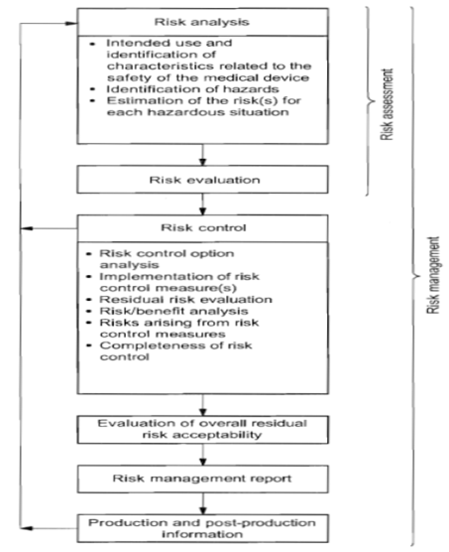

Annexure -1: Stages of Risk management Plan
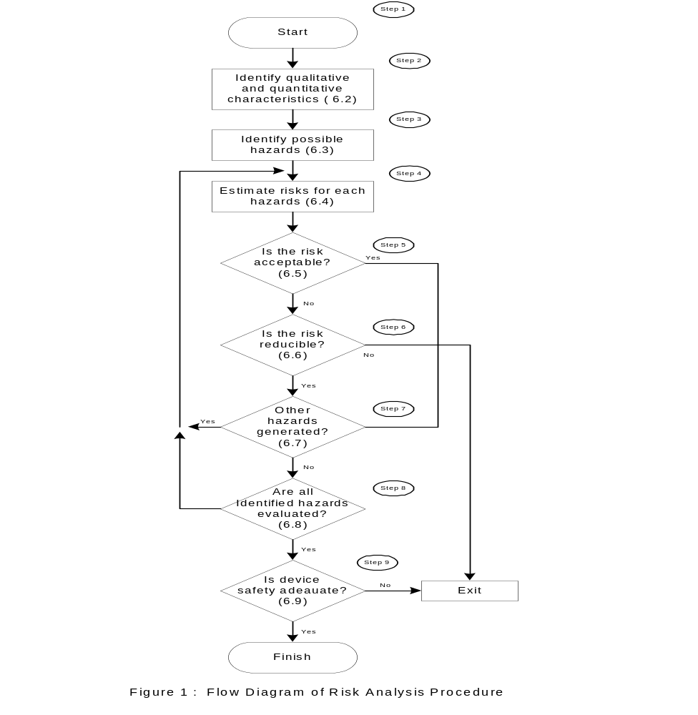

  - Identification of Qualitative and Quantitative Characteristics

    - Unless a new product is developed ,the intrinsic qualitative characteristics may not change. All cases of product modification, for example, may not entail a change in characteristics except for external features. A list of hazards present in the product due to the characteristics of the product shall be drawn. The list of hazards due to characteristics shall include the following,
    - Intended Use:

The device inteded use shall be known and defined In order to assess risk, and determine factors which can cause risk. Eg:
- Misuse
- Cross contamination

    - User Environment and Frequency of Use

The device does not possess any characteristic hazard to the user, however, the device is for Single Use only. Possibility of reuse shall be assessed. Since the device is for personal use, there is no risk to the user environment.

    - Environmental Susceptibility

The effect of environment on the device shall be assessed considering:
- Transport
- Storage
- Handling
- Pilferage

    - Shelf Life

Since these devices have a given shelf life, following factors shall be considered while assessing this hazard:
- Labelling
- Determination of Shelf Life

    - All the hazards listed are envisaged with the existing formulation design of the product. The list is suggestive only and not exhaustive. At the time of evaluation of each hazard individually, several other hazards may be identified which shall be documented by QA Incharge.

  - Identification of Possible Hazards ( Step 3 of Figure 1)

    - Possible hazards shall be listed considering the following classes of hazards:
- Biological Hazards
- Environmental Hazards
- Hazards arising from Functional Failure and Aging

    - Biological Hazards

Following factors shall be considered for this hazard:
- Bioburden (or Microbiological Cleanliness)
- Bioincompatibility
- Inability to maintain Hygienic Conditions

    - Hazards related to manufacturing activities
- Improper material selection
- Improper manufacturing steps
- Improper in-process inspection and acceptance criteria
- Improper validation of processes
- Ouf of Specification Products
- Improper Packaging
- Improper Sterilization
- Lack of determination of adequate shelf life

    - Environmental Hazards

While assessing risk due to this type of hazards, following factors shall be considered:
- Accidental Damage
- Contamination
- Inadequate Labeling
- Inadequate “Instructions for Use”
- Over-complicated Instructions
- Use by unskilled/untrained personnel
- Human Error

    - Hazards Arising from Functional Failure and Aging

Consideration shall be made to possible outcome, if the device fails during use such as breakage in use.

5.5.6 Improper Transportation

  - Estimation of risk for each Hazardous situation-
    - The occurrences are also defined in the five categories of frequency of probability of occurrence levels.

    - The Acceptability Criteria are decided on the control results and frequency of occurrence and remaining residual risk severity. The detail is as given in the following table 2 & 3:

Probability of Occurrence & Consequence of Harm

Table – 2
Probability of Occurrence | Points | Description | Consequence  Of Harm | Points | Description
Negligible / Improbable | 1 | Occurrence nearly impossible | Negligible | 1 | Inconvenience / Temporary Discomfort.
Low / Remote | 2 | Unlikely to occur. | Minor / Marginal | 2 | Temporary Injury or Impairment
Medium / Occasional | 3 | Likely to occur but not  frequently | Major / Critical | 3 | Requires Immediate Medical Intervention  for Temporary Injury or Impairment
High / Probable | 4 | Likely to occur frequently | Serious | 4 | Life Threatening / Permanent Impairment
Very High / Frequent Occurrence | 5 | High probability of occurrence | Catastrophic | 5 | Causes Death
Table-3

Risk = Severity x Probability

Result
0... 6 | As for as possible | (AFAP)
8... 25 | Unacceptable | (N/ACC)
    - Reasonably foreseeable or combinations of events that can result in a hazardous situation has been identified for each hazard so that the associated risk can be assessed and managed-
  - Risk Evaluation & risk acceptability-
    - Organization is committed to provide safe devices to the end user.

- All the risk associated with device shall be identified & each single risk must be assessed.
- Risks are classified as (i) As for as possible (AFAP) & (ii) Unacceptable.

- Risks identified in the AFAP (As for as possible) Zone (Yellow) shall be controlled & mitigated further & a risk benefit analysis carried out & accepted after approval from the top management.

- Any risks remaining shall be identified as unacceptable & assigned to unacceptable risk zone (Red). These risks have to be reduced with a risk benefit analysis approach
Table 4.
Key
Unacceptable risk
As Low As Reasonable-Practicable (AFAP)
  - Risk Control- The following risk control approaches have been used to control the risks-
- Designing for inherent safety by eliminating a particular hazard & reducing the probability of occurrence of the harm or reducing the severity
- Adding protective measures
- Providing information for safety by
- Placing warning in the labeling,
- Restricting the use
- Communicating about improper use, hazards that can occur
- Providing training to the technicians etc.
The measures taken for reducing the risk are detailed in the table 5.

  - Residual risk evaluation: The risk remained after taking control measures shall be evaluated. The residual risks judged acceptable or not acceptable is listed in table 5.

  - Risks arising from risk control measures:
The methods of reduction of established risks shall be revised to determine that new risks have not been generated.
  - Completeness of risk control:
The risks of all hazards shall be evaluated & no hazards are left out.
  - Evaluation of overall residual risk acceptability:
The combined impact of the individual residual risks shall be evaluated and recorded in the risk management summary report.
  - Risk management report:
The summary of the review of the final results of the risk management process shall be prepared. The summary report serve as the high level document that provide evidence that the Anita Industries has ensured that the risk management plan has been satisfactorily fulfilled and results confirm that the required objective has been achieved.
  - Post production information:
During the course of stability study, feedback from market or user any unrecognized hazard if reported, the same will be evaluated. A post production monitoring system is maintained.
Also as a part of regulatory requirements, and as a method of monitoring the residual risks, the data gathetered on the residual risks and any new risk will be considered for the review and updation of the risk management file. The review of risk analysis will be aligned with the updation of the post market surveillance.
  - Adaptation of the safety of the product:
When carrying out a review of the table-5 it is considered that the identified and the associate risks have decreased at reasonable and acceptable levels. It is considered then verified the safety of the product is verified.

- APPLICABLE FORMS

NA

- REFERENCES
EN ISO-14971:2012 Risk Management
Quality System Regulations (21CFR820)
Medical Device Directive (93/42/EEC)

- ABBREVIATIONS:
NA
- SAFETY AND PRECAUTIONS:

Written instructions must be followed

- DISTRIBUTION LIST:

Department | No. of Copies
Quality Assurance | Master copy

